**Walking for Fitness Final Project**

Part 1:

Create 3- Days of Planned Walks Around WPI or your Neighborhood: 3 planned walks that are at least 1.5 miles long using the website, [MilerMeter](https://www.gmap-pedometer.com/) (please insert imagines below like the example)

Example: Walk 1 around WPI, 1.5 miles

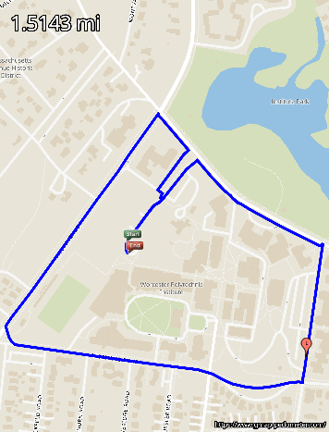

1. Walk 1:

Walk from home, along Institute Road, to Price Chopper and back, 2.0 miles.

1. Walk 2: Start from home, walk along Salisbury street and back, 1.6 miles

1. Walk 3: Start from home, walk around gateway and faraday house and back, 1.6 miles

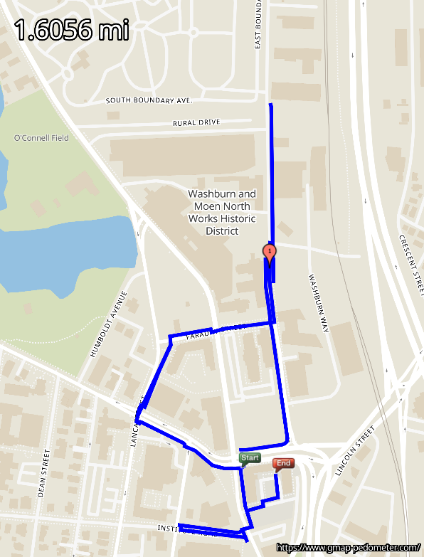

**Part 2:**

Create a 5 days of healthy dinner meals that you would enjoy:

Remember to:

1. Make at least half of your grains, whole grain.
2. Include at least one food from the Beans and Pea Vegetable Subgroup
3. Include at least one vegetable from the Dark – Green Vegetable Subgroup.
4. Have a variety of proteins. Each protein food may be used no more than two times.

Examples of each are below, feel free to use other examples from your research:

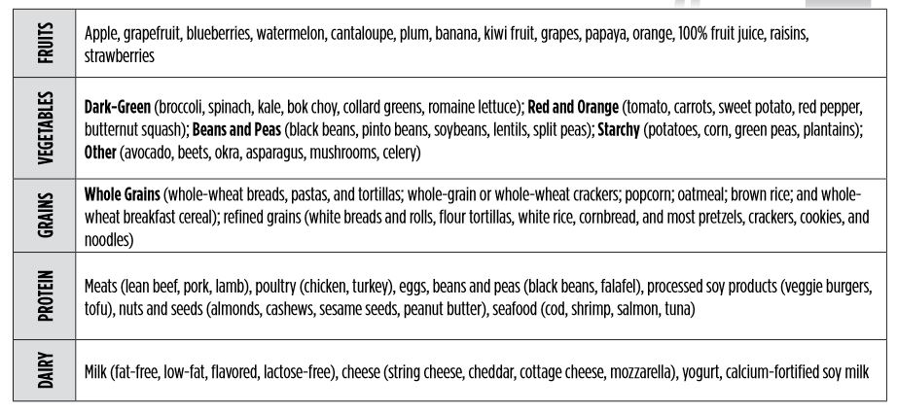

Fill in your five meals below:

|  |  |  |  |  |  |
| --- | --- | --- | --- | --- | --- |
|  | Day 1 | Day 2 | Day 3 | Day 4 | Day 5 |
| Fruits | Watermelon | Plum | Banana | Grapes | 100% fruit juice |
| Vegetables | Broccoli  Soybeans | Spinach  Tomato | Mushrooms  Romaine Lettuce | Corn  Green peas | Celery  Lentils |
| Grains | Whole-wheat breads | Pasta | White rice | Noodles | Whole-wheat cereal |
| Protein | Pork | Lean beef | Chicken | Shrimp | Tofu |
| Dairy | Milk (fat free) | yogurt | Soy milk | yogurt | Fat free milk |

**Part 3:**

Write a 500 word summary detailing the benefits of 150 minutes- 300 minutes of physical activity. Please make sure you include information and examples from this class.

**Benefits of active physical exercising**

It is well known that exercising has a lot of benefits. Physically or mentally, exercising is essential for people nowadays.

First of all, regular moderate-to-vigorous physical activity reduces the risk of many adverse health outcomes. One of the most significant benefits of physical activity is that it burns calories and reduces weight, which reduces the rate of being obesity. Obesity brings a lot of problems, like diabetes mellitus, cardiovascular disease (including heart disease and stroke), different type of cancer (including lung cancer) and dementia diseases. Even one have already being diagnosis with such diseases, one may still remain in a acceptable range with enough regular physical exercises. Recently, I was diagnosis with polycystic ovary syndrome, which is a set of symptoms due to elevated androgens (male hormones) in females. With regular exercise and reasonable diet, I can control the hormone level in my body and restrict these syndrome in a acceptable range. Moreover, exercising improves people’s cardiorespiratory fitness. Take the Covid-19 as an example, with no effective drugs for this disease now, people who have a healthier lung and a stronger immune system recovers better from this disease. Another important benefit from physical activity is that it makes people look better.

In addition, physical activity adjusts people’s mental state. From studies, it is known that regular moderate exercise improves your sleeping quality. Hence, it would improved cognition, which helps with a bunch of other mental health problems such as anxiety and depression. These are the benefits for your brain provided by exercising. As the book has said, compared to inactive people, people who do greater amounts of moderate- or vigorous-intensity physical activity may experience improvements in cognition, including performance on academic achievement tests, and performance on neuropsychological tests, such as those involving mental processing speed, memory, and executive function. For students, this is a great way to improve grades while remaining a healthy life. In addition to feeling better, adults who are more physically active sleep better. Greater volumes of moderateto-vigorous physical activity are associated with reduced sleep latency (taking less time to fall asleep), improved sleep effciency (higher percentage of time in bed actually sleeping), improved sleep quality, and more deep sleep. Physical activity will also make people feel less sleepiness during daytime, which not only make the working time more effective, but also make the night time sleep more effective.

Last but not least, regular physical activity is a good way for people to make friends. The majority of exercises need to play with a friend. People can remain their friendship with regular physical activities together. On the other hand, people can make new friends when doing exercise. Exercising outdoor is a great opportunity to meet people who are doing the same activity. With similar hobbits, a meet in the playground may evolve into a great long friendship. Exercises also require teamwork. So corporations should handle regular exercising context for workers so that they keep an enthusiasm with their team.